Certification Project II
Microsoft SQL Server

Internship Program: Data Science and Machine Learning Program
Student: Akram M'Tir
Date: March 2025

Table of Contents
Database creation 2
Tables creation 3
Check Database and table creation 5
Data insertion 6
Check Primary Foreign Keys and Indexes 7
ER Diagram 9
6 Find Out the Highest and Lowest Amount 10
7 Get the Unique Count of customerName from customers 11
8 Create a View cust_payment 12
9 Create a Stored Procedure for Classic Cars Product Line 15
10 Create a Function to Get creditLimit of Customers Less Than 96800 16
Difference Between Stored Procedure and Function 16
11 Create a Trigger to Store Transaction Record for Employee Table 17
12 Create a Trigger to Display Customer Number If Amount > 10,000 19
13 Create Users, Roles, and Logins 20
14 Schedule a Job for Database Backup 22
Msdb in SQL Server? 22
Enable SQL Server Agent 23
Manually Run the Job to test 24
Verify If the Backup Was Created 24
15. Open Activity Monitor & List Observations 28
16. Migrate SQL Server to Azure 30

Database creation

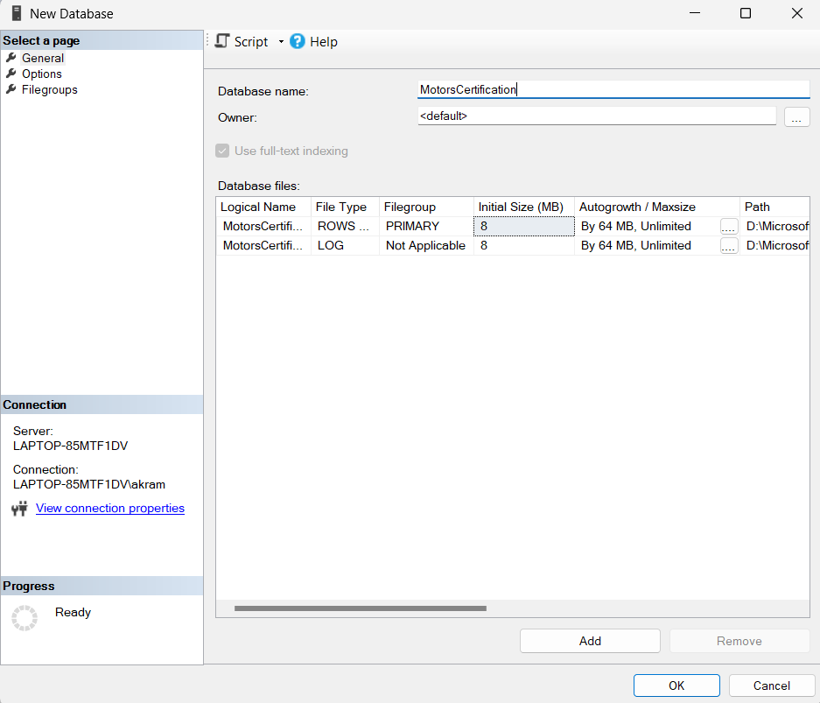
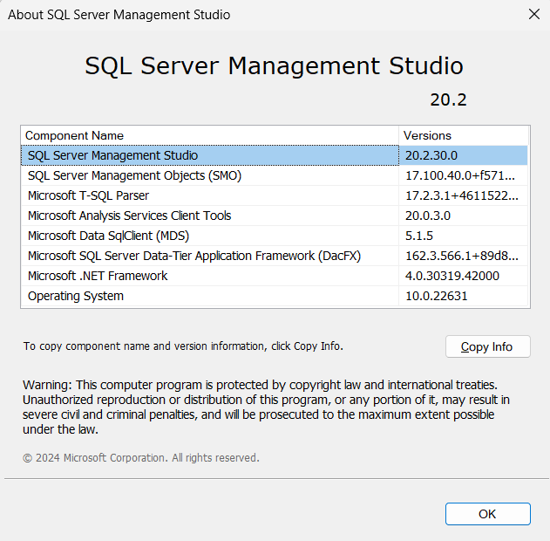

Tables creation

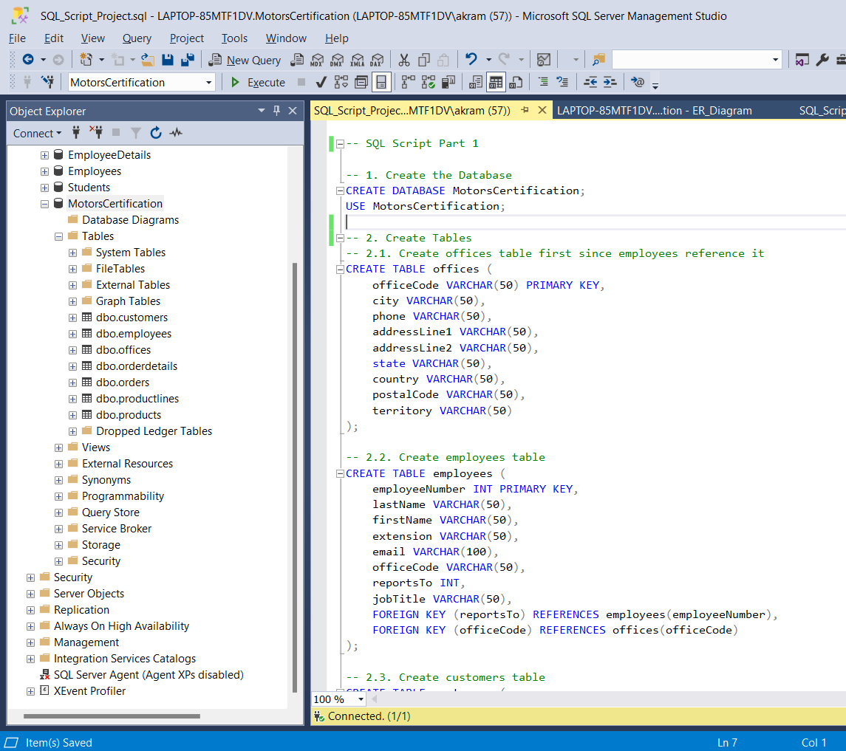

Check Database and table creation

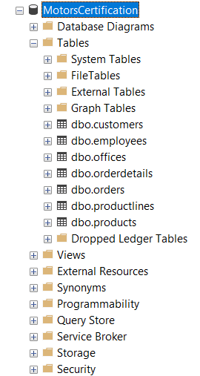

Data insertion

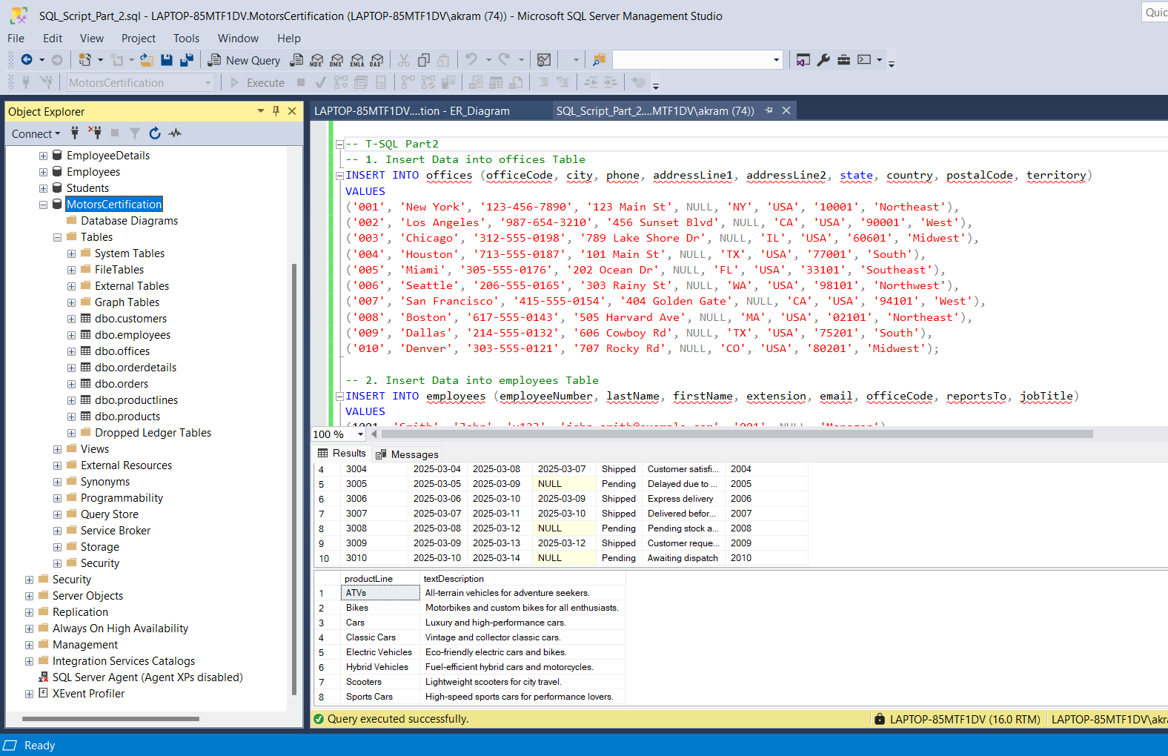

Check Primary Foreign Keys and Indexes

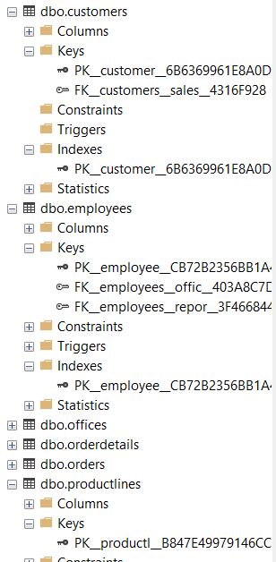

ER Diagram

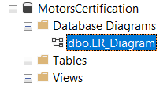

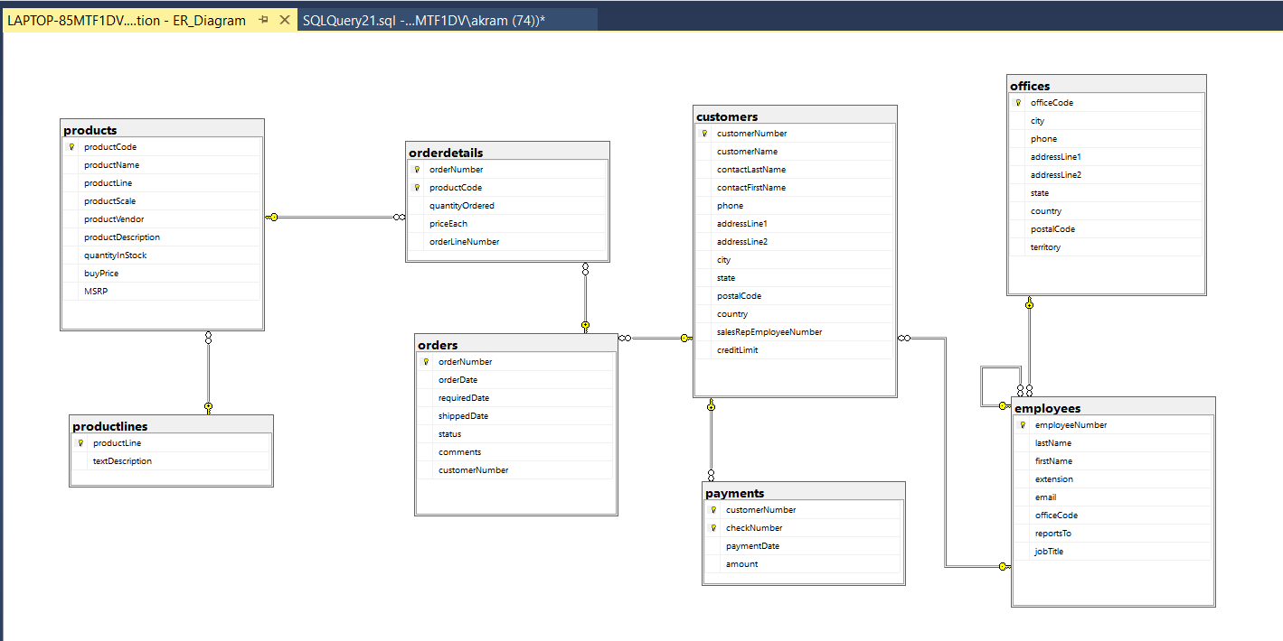

6 Find Out the Highest and Lowest Amount

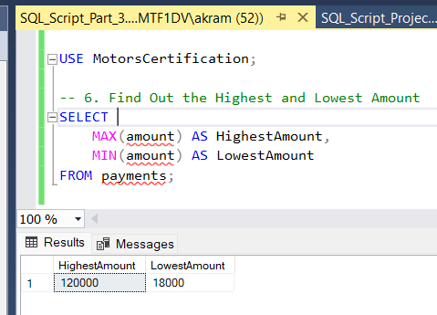

7 Get the Unique Count of customerName from customers

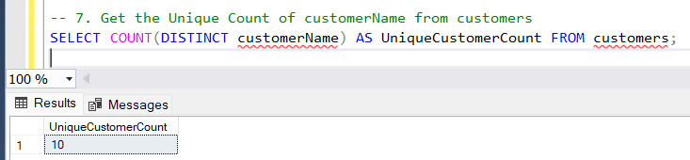

8 Create a View cust_payment

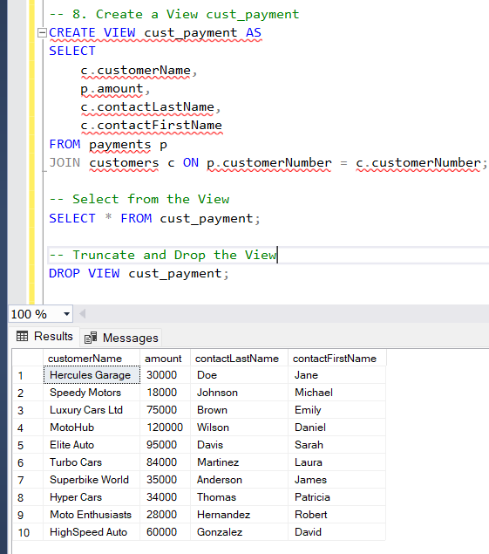

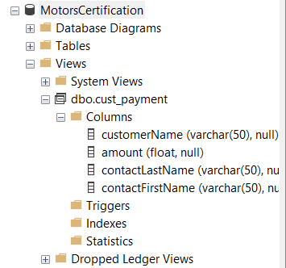

9 Create a Stored Procedure for Classic Cars Product Line
This stored procedure will display productLine for "Classic Cars".

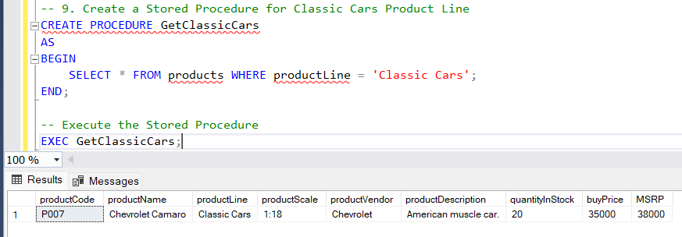

10 Create a Function to Get creditLimit of Customers Less Than 96800
This function will return a table of customers with creditLimit less than 96,800.

Difference Between Stored Procedure and Function
Feature | Stored Procedure | Function
Purpose | Performs an action (e.g., inserting, updating, or deleting data) | Returns a value or table (used for calculations or queries)
Return Type | Can return multiple result sets or nothing | Must return a single value or a table
Usage in Queries | Cannot be used inside SELECT statements | Can be used inside SELECT, WHERE, JOIN
Can Modify Data? | ✅ Yes (INSERT, UPDATE, DELETE) | ❌ No (Only SELECT is allowed)
Calling Method | EXEC ProcedureName | SELECT * FROM FunctionName()
Example Use Case | Retrieve product details, process orders, update stock | Calculate tax, filter customers by credit limit

11 Create a Trigger to Store Transaction Record for Employee Table
This trigger will store a transaction record whenever a new employee is inserted. It will log employeeNumber, lastName, firstName, and officeCode.

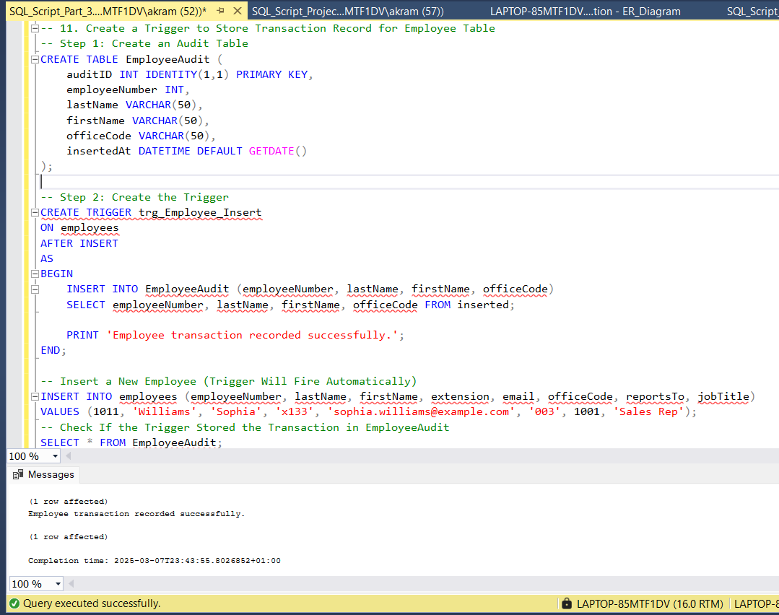
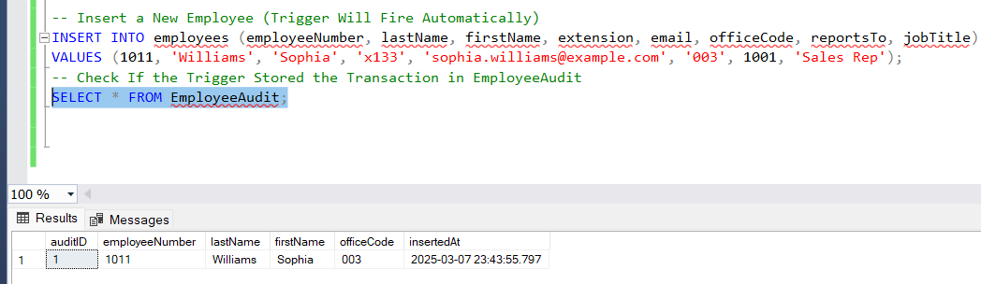

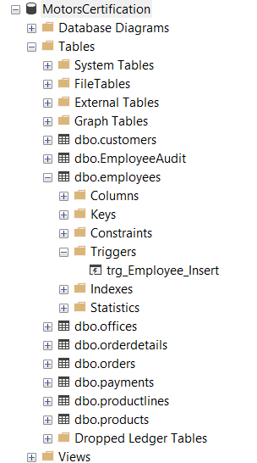

12 Create a Trigger to Display Customer Number If Amount > 10,000
Whenever a new payment is added, if the amount is greater than 10,000, the trigger will print the customerNumber.

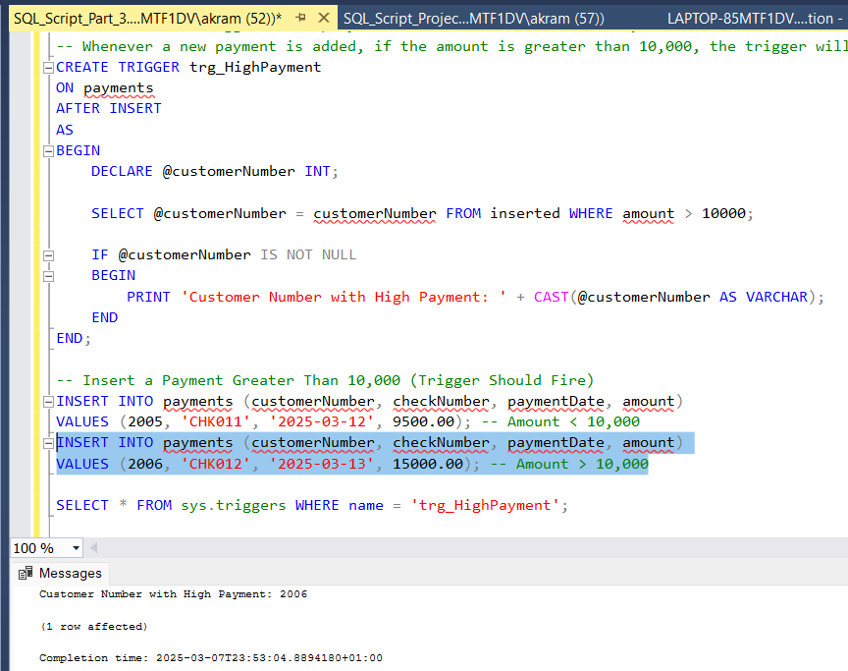
Insert a Payment Greater Than 10,000 (Trigger Should Fire)

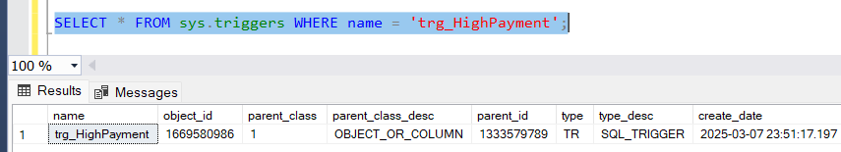

13 Create Users, Roles, and Logins
Step 1: Create Logins
Step 2: Create Database Users
Step 3: Create Roles
Step 4: Assign Permissions

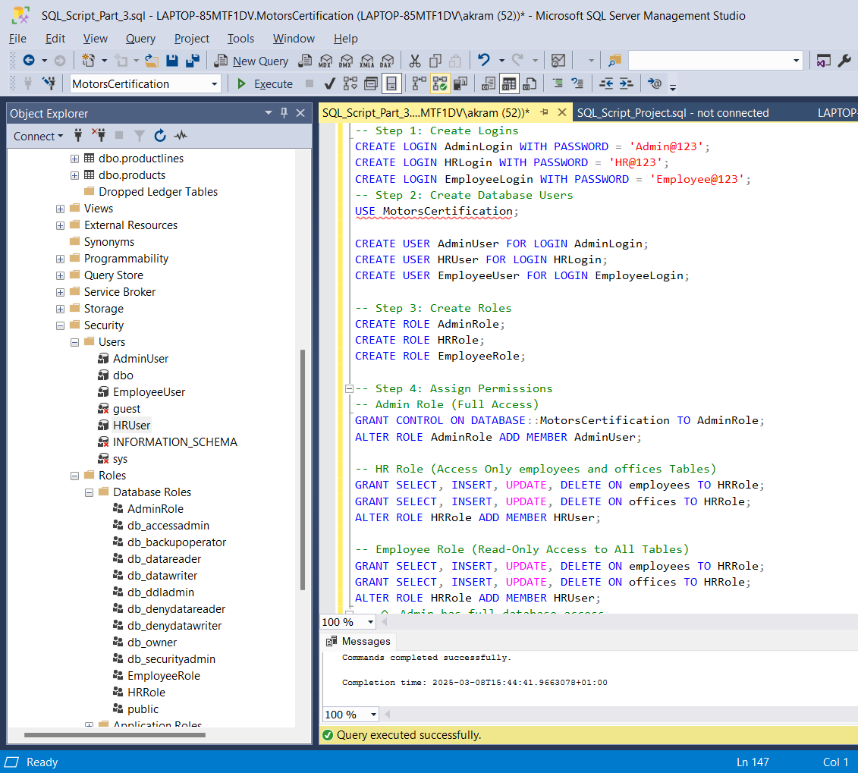

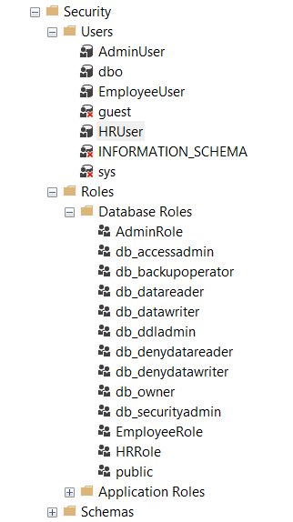

14 Schedule a Job for Database Backup
This job will automatically back up the database on a scheduled basis.

Msdb in SQL Server?
msdb is a system database in SQL Server that is used by SQL Server Agent for scheduling jobs, alerts, and backups.
We are creating a SQL Server Agent Job to automatically back up the database. SQL Server Agent uses msdb to store job-related information such as:
- Scheduled Jobs
- Backup History
- Alerts & Notifications
- Job Steps and Execution History

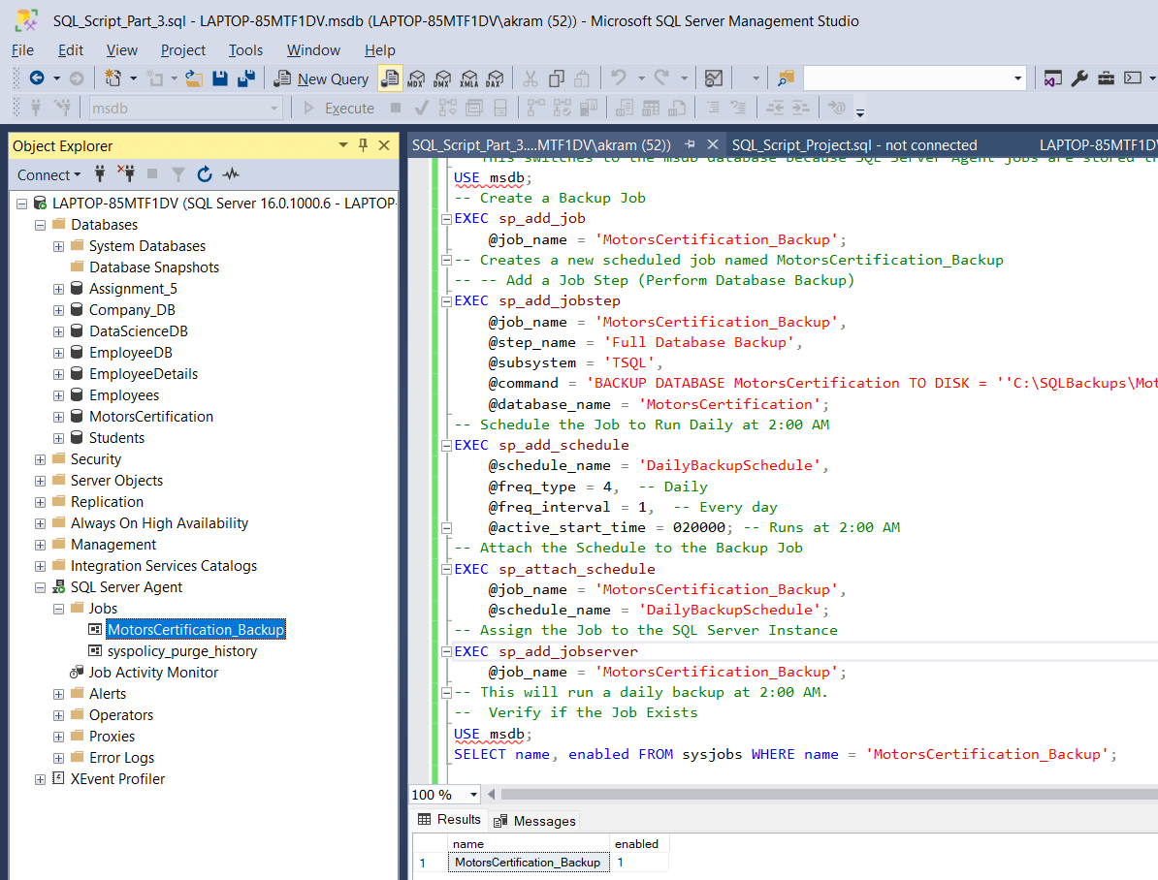

Enable SQL Server Agent

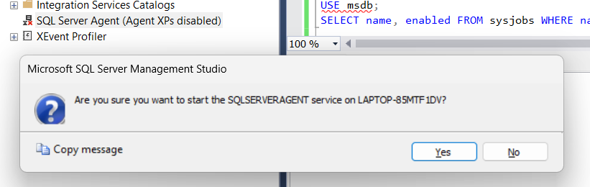

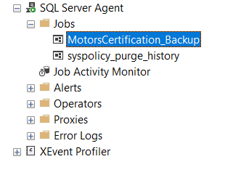
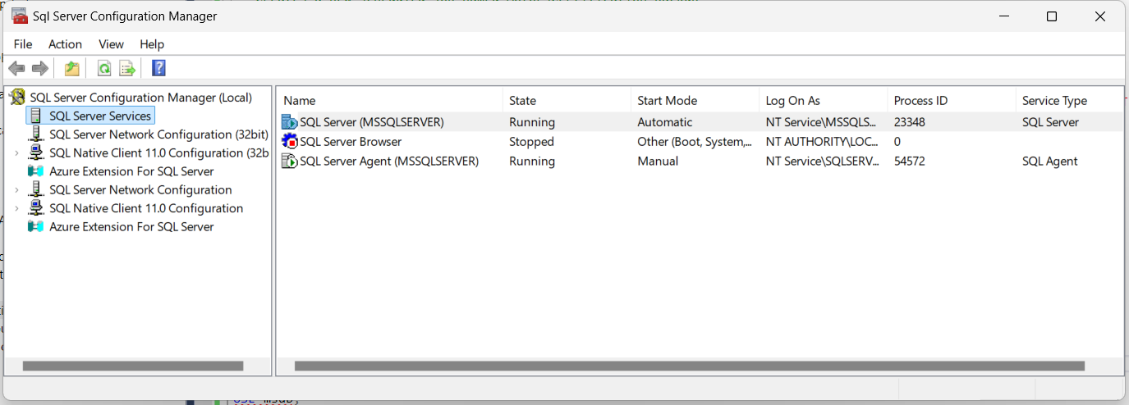

Manually Run the Job to test

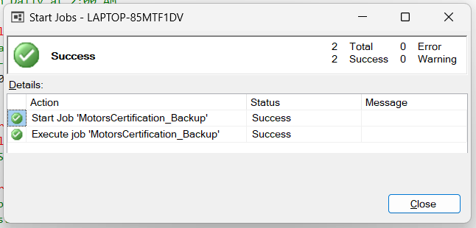

Verify If the Backup Was Created

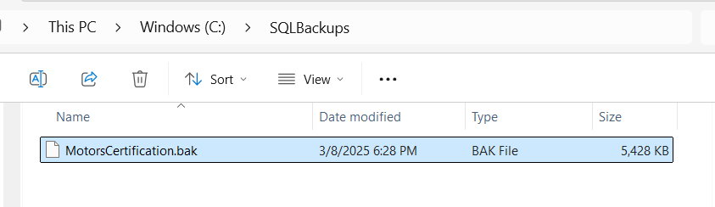
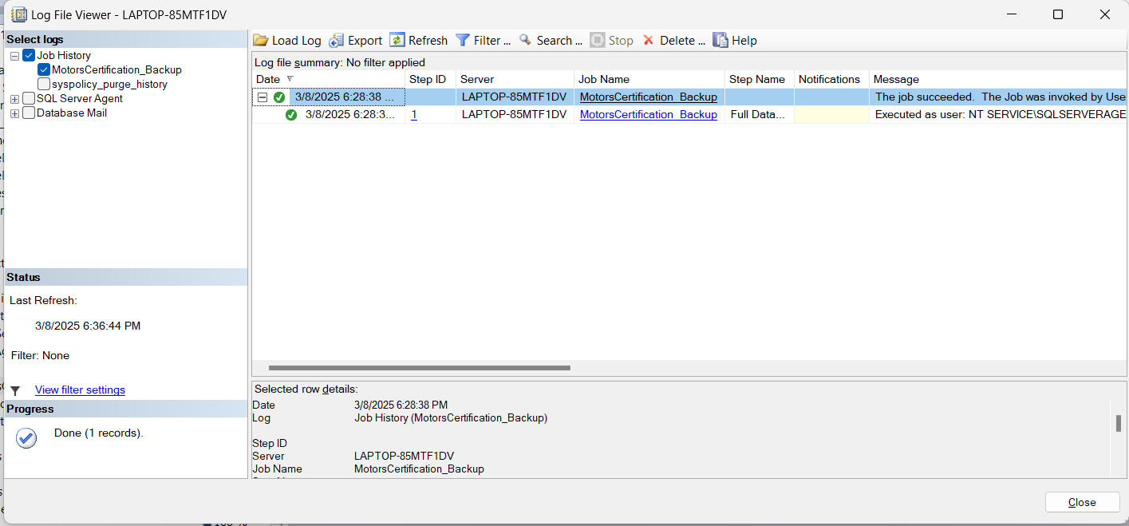

15. Open Activity Monitor & List Observations
Open Activity Monitor:

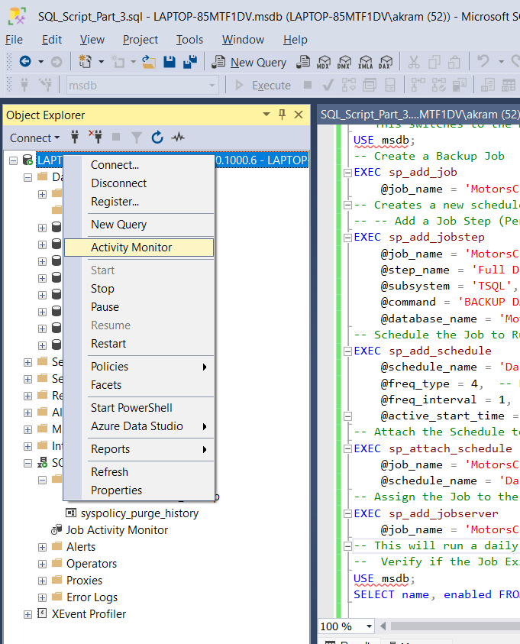

Observations in Activity Monitor:
- Processes:
  - Some background system processes are always running.
  - Query execution threads are active based on workload.
- Resource Waits:
  - No significant waits in a low-traffic environment.
  - Increased wait times may indicate locks or performance bottlenecks.
- Active Expensive Queries:
  - Expensive queries usually involve large joins or missing indexes.
  - CPU-intensive queries may indicate performance tuning is needed.
Recommendation:
Monitor CPU usage, I/O waits, and blocking queries for optimization.

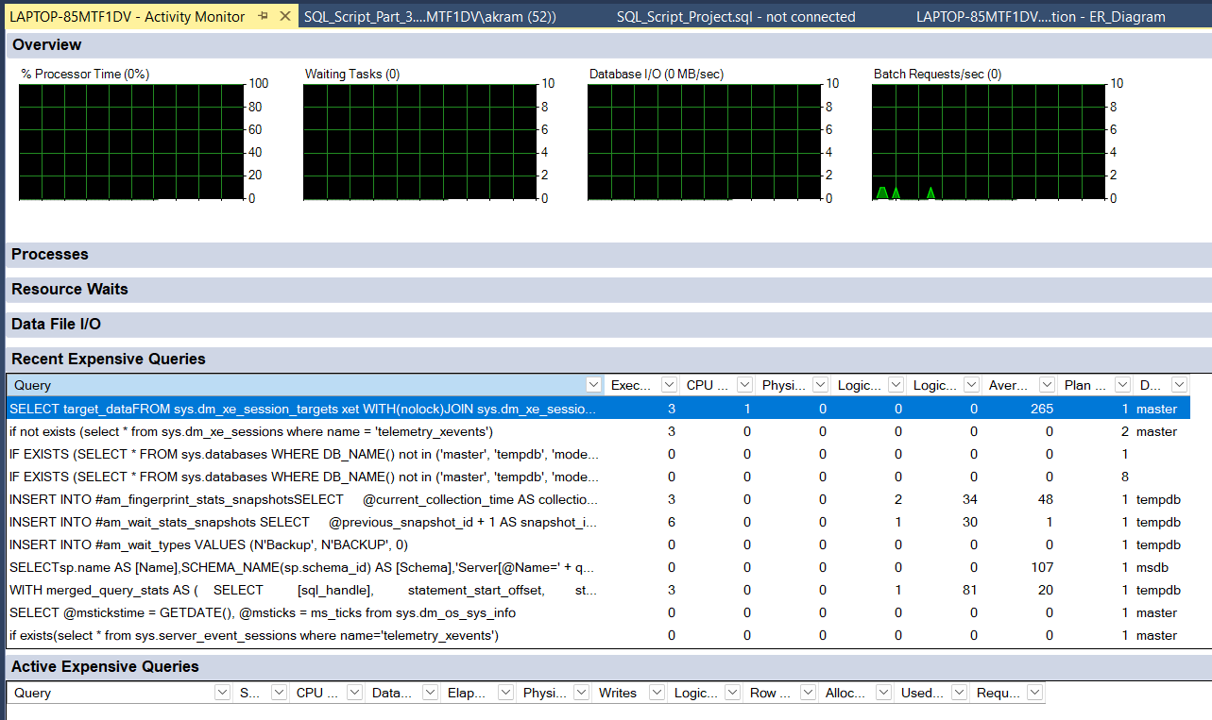

16. Migrate SQL Server to Azure
Steps to Migrate SQL Server Database to Azure SQL Database
- Use Azure Data Migration Assistant (DMA)
  - Download and install Azure DMA.
  - Analyze the database for compatibility issues.
  - Migrate schema and data.
- Use SQL Server Management Studio (SSMS)
  - Right-click the database → Tasks → Deploy Database to Microsoft Azure SQL Database.
  - Provide Azure SQL Server credentials.
  - Complete the migration.
- Use Azure Database Migration Service (DMS)
  - In Azure Portal, create a Migration Service.
  - Select Online or Offline Migration.
  - Provide source and target database details.
  - Start data transfer.

